A World War Two Christmas

Teacher Note: The links to the YouTube clips referenced in this worksheet can be found via www.activehistory.co.uk on this page: http://goo.gl/DoZNSp

The immediate impact of the war on Christmas, 1939-31
The outbreak of World War Two meant that Christmas for the next six years was characterised by ever-increasing hardship. The Imperial War Museum states that 1,000,000 British children were evacuated; 130,000 suffered the loss of a parent on active service; a further 16,000 were sent overseas; and 7,736 died as a direct result of enemy action.

Christmas 1939
The King’s Speech
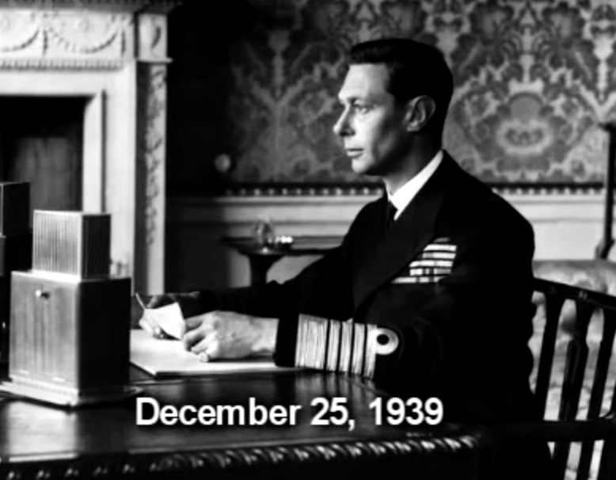
At 3pm on Christmas Day 1939, King George VI broadcast his Christmas message from Sandringham on the BBC. This was so popular with listeners that it became an annual ritual that continues to this day:

“The festival which we all know as Christmas is, above all, the festival of peace and of the home. Among all free peoples the love of peace is profound, for this alone gives security to the home. But true peace is in the hearts of men, and it is the tragedy of this time that there are powerful countries whose whole direction and policy are based on aggression and the suppression of all that we hold dear for mankind. I believe from my heart that the cause which binds together my peoples and our gallant and faithful Allies is the cause of Christian civilisation. On no other basis can a true civilisation be built. Let us remember this through the dark times ahead of us and when we are making the peace for which all men pray. A new year is at hand. We cannot tell which it will bring. If it brings peace how thankful we shall all be. If it brings continued struggle, we shall remain undaunted”.

Task: Watch the performance of Colin Firth, followed by an original audio recording of the King. Does the genuine audio sound close to the performance of Colin Firth? Can you tell in the audio that the King suffered from a stutter?

Christmas 1940
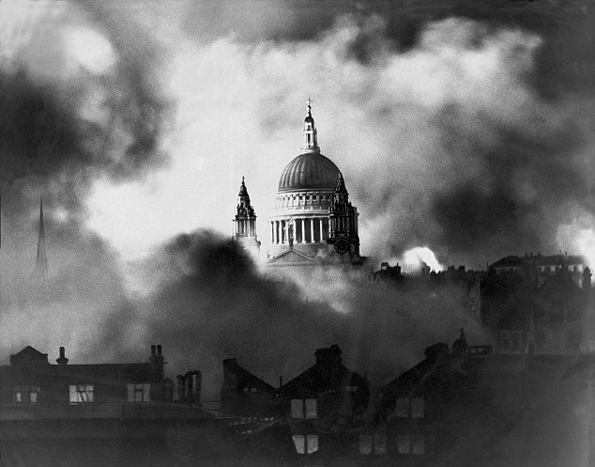
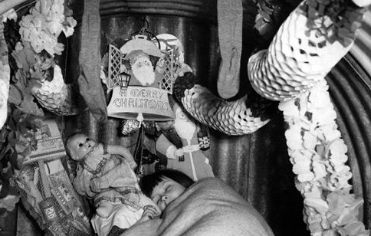
In 1940, Chamberlain resigned as Prime Minister and was replaced by Winston Churchill. France fell to the Nazis after just six weeks and the British army were evacuated from the beaches of Dunkirk. Hitler then attempted to destroy the British Air Force in the skies over the south coast (the Battle of Britain) and when this failed he was persuaded by Goering to bomb British cities in an attempt to destroy British morale – (the Blitz). Rationing was introduced and children were evacuated to the countryside. Many families found themselves celebrating Christmas in a bomb shelter like the one show in the photograph.

Mercifully, there was an unofficial postponement of the bombing by both sides from Christmas Eve 1940 until the 27th December. However, Sunday 29 December marked one of the fiercest bombing raids of the whole Blitz - so fierce it caused what became known as the Second Great Fire of London. As the City became a raging inferno, the dome of St Paul's Cathedral was photographed towering unscathed above the carnage. This became one of the most powerful images of the whole war.

Task:
In 1941, the British Ministry of Information produced a short propaganda film called “Christmas under Fire” (10m) designed to persuade America to join the war against the Nazis.
Before watching the film: What things do you expect it will show? What tone will in adopt?
After watching the film: How far did you anticipate correctly?

Christmas 1941
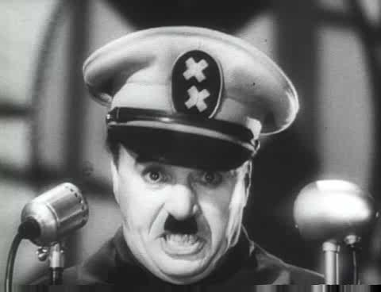
• At the beginning of 1941, Britain stood alone against Nazi Germany. However, Hitler’s invasion of the USSR in Operation Barbarossa and Japan’s attack on the US Navy at Pearl Harbour meant that the two emerging Superpowers joined the war against Hitler.
• Entertainment over the festive period this included Charlie Chaplin satirising Hitler in "The Great Dictator" (4m) and Bing Crosby’s “White Christmas”.

• Churchill broadcast the following Christmas speech from the White House, where he was visiting President Roosevelt to discuss war strategy:

“This is a strange Christmas Eve. Almost the whole world is locked in deadly struggle, and, with the most terrible weapons which science can devise, the nations advance upon each other…Here, in the midst of war, raging and roaring over all the lands and seas…we have tonight the peace of the spirit in each cottage home and in every generous heart. Therefore we may cast aside for this night at least the cares and dangers which beset us, and make for the children an evening of happiness in a world of storm. Here, then, for one night only, each home throughout the English-speaking world should be a brightly-lighted island of happiness and peace. Let the children have their night of fun and laughter. Let the gifts of Father Christmas delight their play. Let us grown-ups share to the full in their unstinted pleasures before we turn again to the stern task and the formidable years that lie before us, resolved that, by our sacrifice and daring, these same children shall not be robbed of their inheritance or denied their right to live in a free and decent world. And so, in God's mercy, a happy Christmas to you all”.

Discussion point: Is this speech better than that of the King that you read earlier? Why? Is Chaplin’s better than both of them?

Christmas 1942
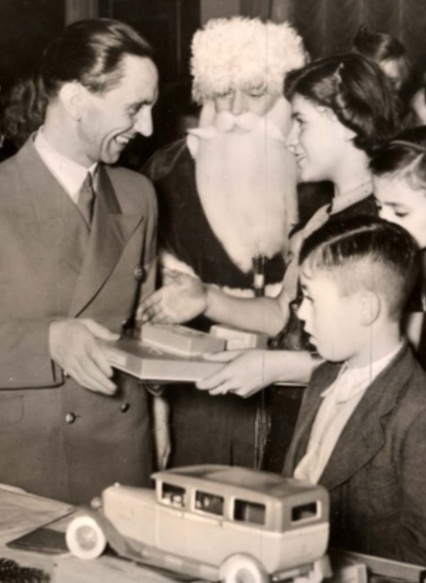
▪ On Christmas Day 1942, Radio Moscow broadcast a simple message to the members of General Friedrich Paulus’s 6th Army besieged in the city of Stalingrad. To the background sound of a ticking clock came the message: “Every seven seconds a German soldier dies in Russia. Stalingrad is a mass grave.”
▪ With a relentlessness that mirrored a battle which had begun four months earlier and had brought the German advance into the Soviet Union to a grinding halt, the message was repeated throughout the day.
▪ As temperatures dropped to minus 25C, encircled by an ever more confident Red Army, with their supplies and weapons rapidly diminishing, the same troops who had victoriously goosestepped down through Paris fewer than 30 months earlier were now on the brink of utter collapse.
▪ On the same day, Goebbels (pictured) delivered a broadcast to the German people with a (faked) link-up to soldiers in Stalingrad telling everyone how well things were going. The Pope also delivered a Christmas speech condemning the persecution of the Jews.

Christmas 1943

Extension Task: Conduct your own research to develop this information sheet (in the same style as what has gone before) with details about Christmas 1943.

Christmas 1944
Two years on from that freezing Christmas of 1942, the Red Army was closing fast on the German capital. Here, according to historian Antony Beevor, a gallows humour prevailed. In anticipation of their traditionally beloved Christmas, Berliners joked about the ideal Yuletide present. “Be practical,” they said. “Give a coffin.”

How the war affected Christmas
• Use the following word list to complete the gaps.
• In the square bracket after each answer, write a number between 1-5 to reflect how confident you are that you have the right answer (with 5 being ‘very confident’).
• When you mark these as a class, you will GAIN that amount of points for each answer you got correct, but LOSE the same amount of points if you get it wrong!

blackout | rabbits | breadcrumbs | munitions | bulldog | dogs | crackers
murkey | clothes | carrots | chains | soap | flour | propaganda
squanderbug | gas masks | Americans | consumer | hitlerflea | electrical | ANZACs

Decorations
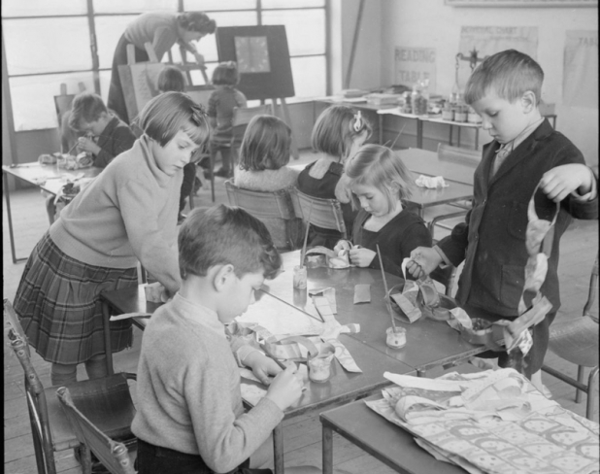
• With paper in such short supply, wrapping paper had been prohibited for most of the war so families had to improvise, while Christmas cards were small and were printed on flimsy paper.
• ___________________ [ ] regulations killed off the traditional sight of lit-up Christmas trees in people's front windows.
• In this photograph (left), pupils at Fen Ditton Junior School in Cambridgeshire are making Christmas decorations in 1944. They are creating paper ___________________ [ ], a popular Christmas decoration. In wartime, these would be made from scraps of old paper or painted newspapers. Very few decorations were available to buy in the shops.

Food
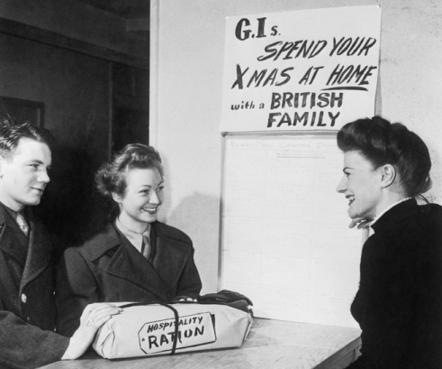
• Turkeys were scarce and expensive. Instead, the Ministry of Food issued alternative recipes including mock turkey or ___________________ [ ]. This involved moulding a ‘turkey’ made of sausage meat, vegetables and ___________________ [ ].
• A family of four's weekly meat ration wouldn't even cover the cost of a small chicken. One alternative was home-reared chickens or ___________________ [ ], much to the shock of young children who often regarded them as pets!
• Many GIs who were away from home on Christmas welcomed the chance to spend the day with British families. The ___________________, [ ] often brought lavish gifts of food to their hosts, which were gratefully received (see photo).

Toys
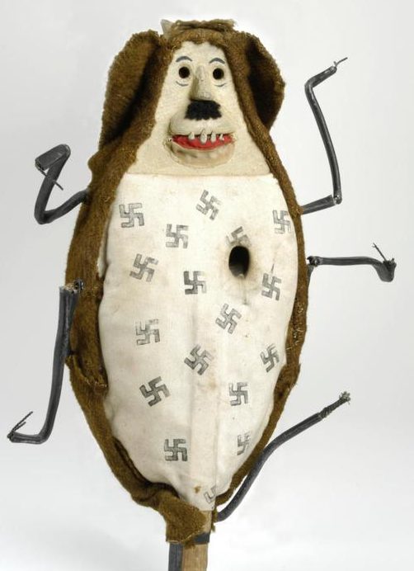
• Many British toy manufacturers shut down during the war, instead producing ___________________ [ ] or other items to help the fight.
• Almost £10 million in war bonds was sold in the week before Christmas.
• Practical gifts were in vogue - gardening tools, books, bottling jars, seeds. Gardening magazines recommended a bag of fertilizer as a gift, and the most popular present for Christmas 1940 was ___________________ [ ]!
• The “___________________ [ ]” (pictured) first appeared in press adverts, but quickly developed a life of its own after use in several poster designs, urging people to save for the war effort rather than helping Hitler by ‘squandering’ their money on ___________________ [ ] goods. Members of the public made their own effigies from materials like papier mache, using them for target practice and in town parades culminating in the symbolic hanging of the creature!

